Users and Groups Administration in Linux

Users and Groups
• User → A person (or process) that uses the operating system services.
• Group → A collection of users. Groups are used to manage permissions more easily.

Types of Users in Linux
- Super user / Root (UID = 0)
- Has all permissions and privileges.
- Can manage users, groups, services, hardware, and files.
2. Static System Users (UID 1–200)
- Created automatically by the OS.
- Examples: daemon, bin, sys.
3. System Users (UID 201–999)
- Created when packages or services are installed.
- Example: apache (for web server), named (DNS), chronyd (time sync).
4. Normal Users (UID 1000–60000)
- Created manually by the system administrator.
- Have limited permissions.

Important User & Group Files
- Cat /etc/passwd :

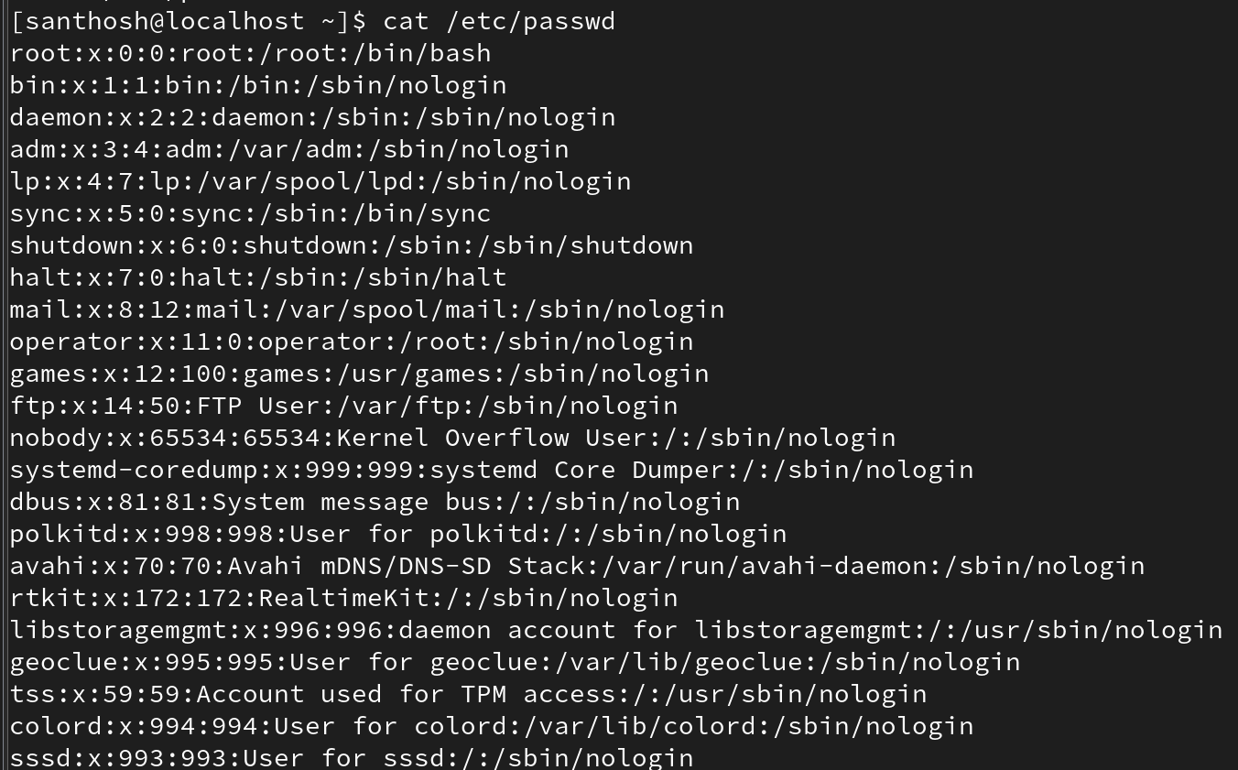

- cat /etc/shadow:

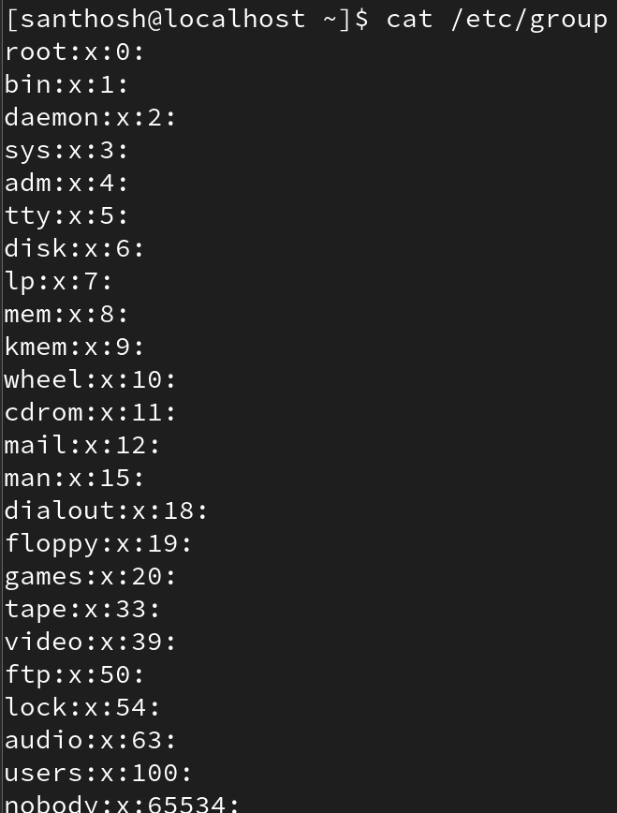

- cat /etc/group:

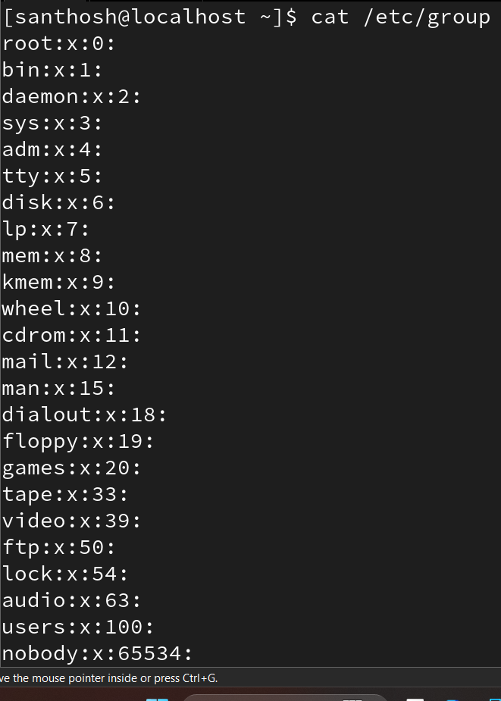

- cat /etc/gshadow:

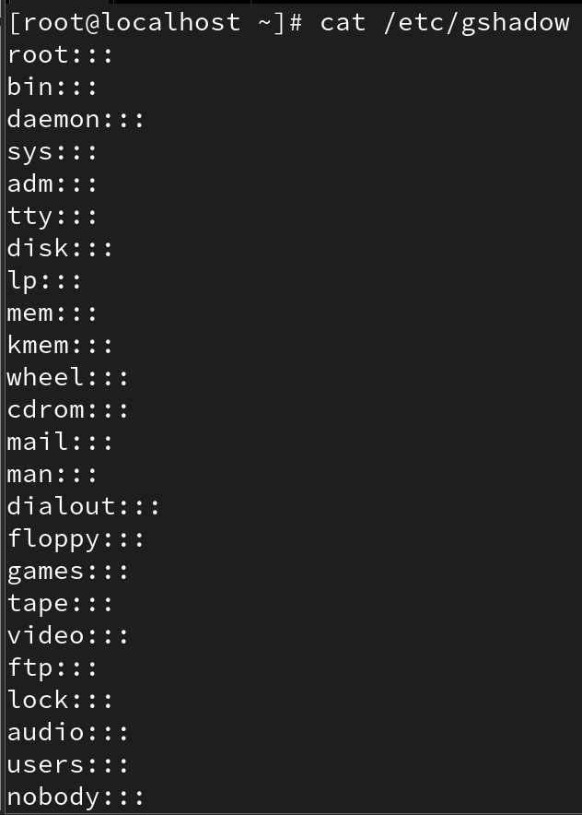

- Cat /etc/passwd
Format:
username : password_mask : UID : GID : comment : home_directory : login_shell
• username → Login name of the user.

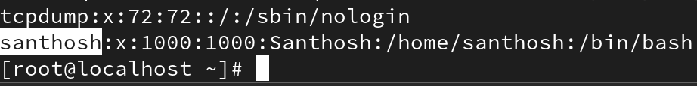

• password_mask (x) → Password is not stored here, only a placeholder (x). Actual password is in /etc/shadow.

• UID → Unique User ID (0 = root, 1000+ = normal users).

• GID → Primary Group ID (refers to /etc/group).

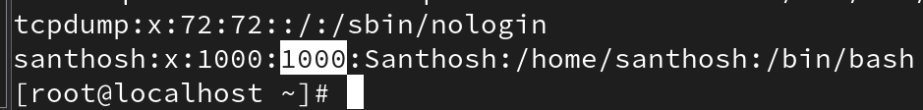

• comment → Description about the user (full name, etc.).

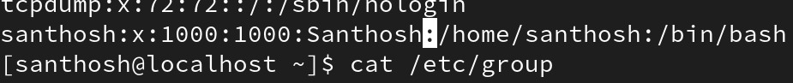

• home_directory → Default directory after login (usually /home/username).

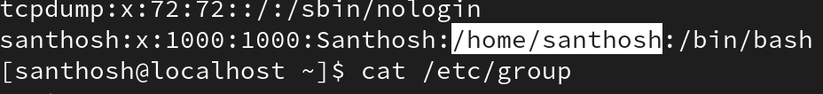

• login_shell → Default shell (/bin/bash, /bin/sh, etc.).

- cat /etc/shadow

• username → Same as in /etc/passwd.

• encrypted_password → Encrypted (hashed) password. ! or * means account is locked.

• last_change → Days since 1 Jan 1970 when password was last changed.

• min → Minimum days before password can be changed.
• max → Maximum days before password must be changed.

• warn → Number of days before expiry when user is warned.

• inactive → Days after expiry before account is disabled.

• expire → Absolute account expiry date (days since 1970).

• reserved → Future use (kept empty).

4] cat /etc/group

• groupname → Name of the group.
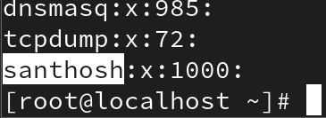

• password → Rarely used, usually x. Group passwords are in /etc/gshadow.
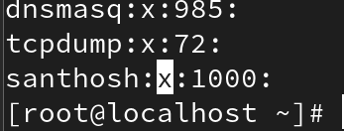

• GID → Group ID (matches with users’ GID).
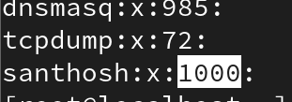

• members → Comma-separated list of users in this group.

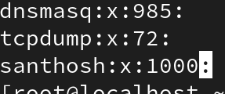
5] cat /etc/gshadow

• groupname → Group name.
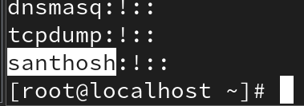

• group_password → Encrypted group password (rarely used).
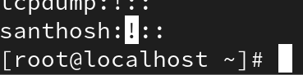

• admins → Users who can manage the group.

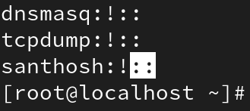

• members → Regular group members.
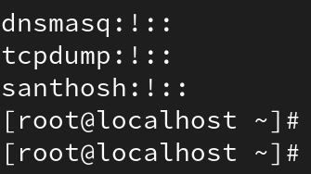

User Management Commands
• Create user: useradd username
• View users: cat /etc/passwd

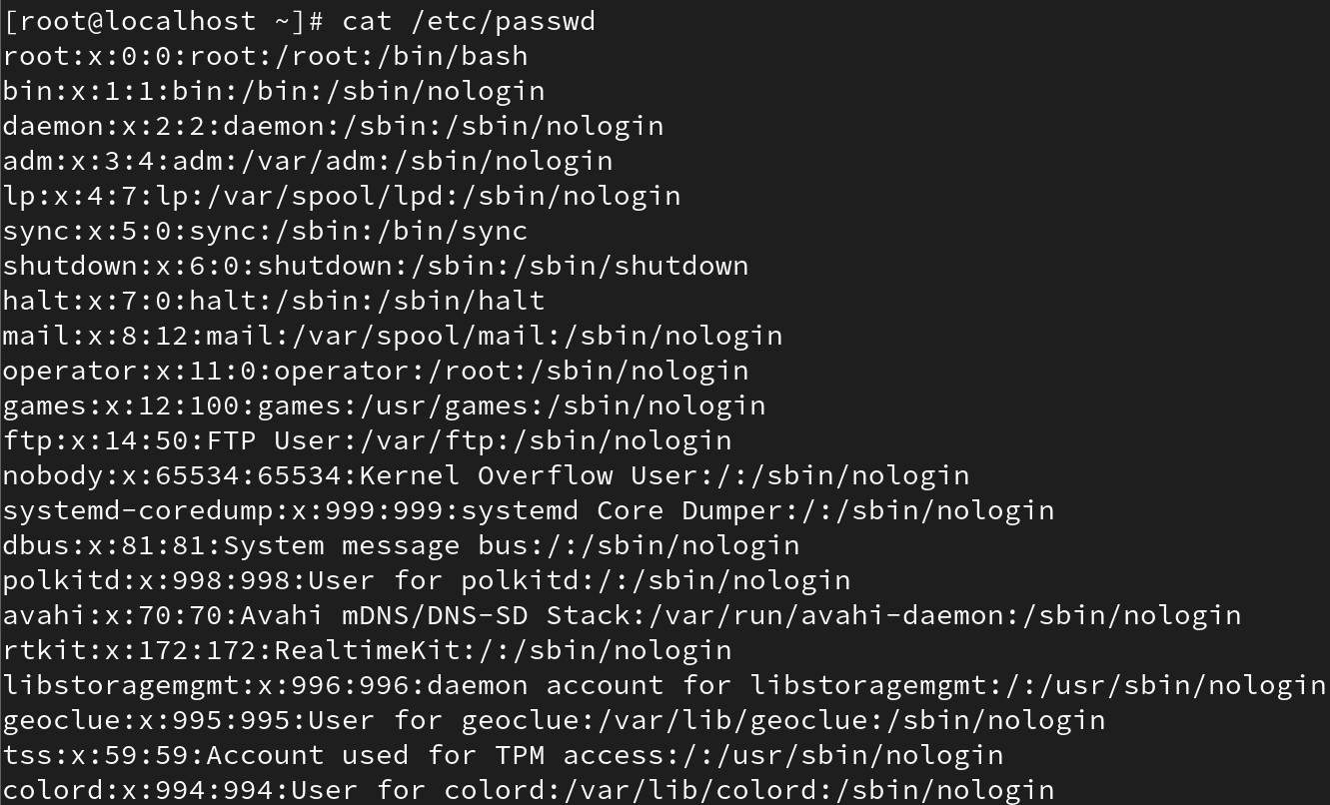

• Check user ID & group info:
id username

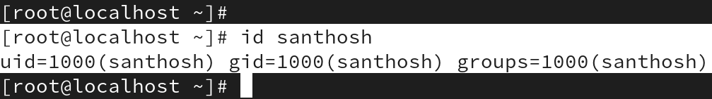

id -un username # shows username
id -gn username # shows primary group
id -Gn username #shows primary and secondary
id -u username #shows user id
id -g username #shows group id

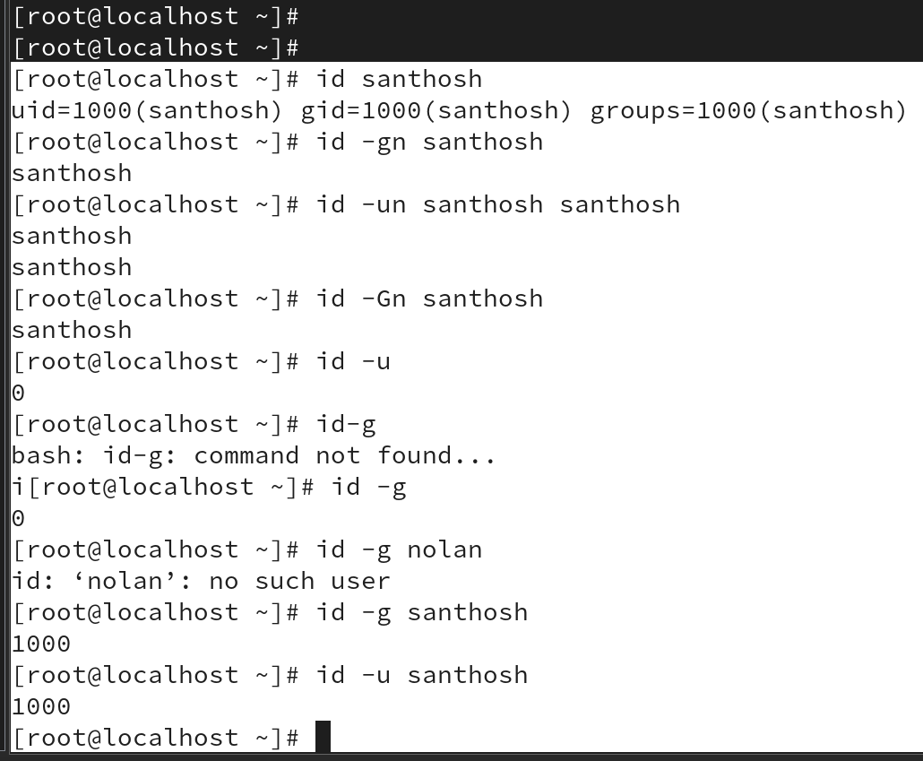

• Set password: passwd username

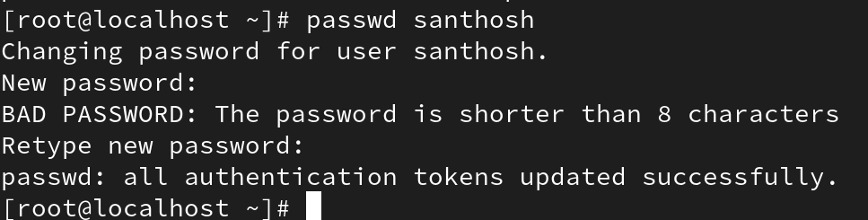

• Remove password: passwd -d username

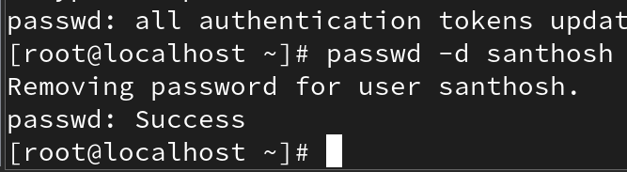

• Delete user: userdel username
• Delete user with home/mail: userdel -r username

